Checking /user/acadgild/hadoop directory exists in the HDFS root directory.

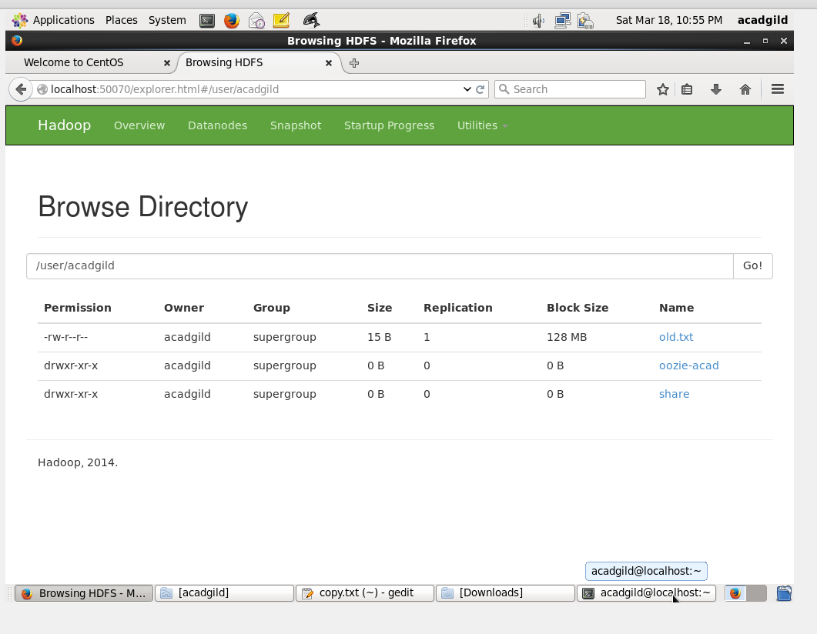

Creating the Hadoop directory and subdirectory:

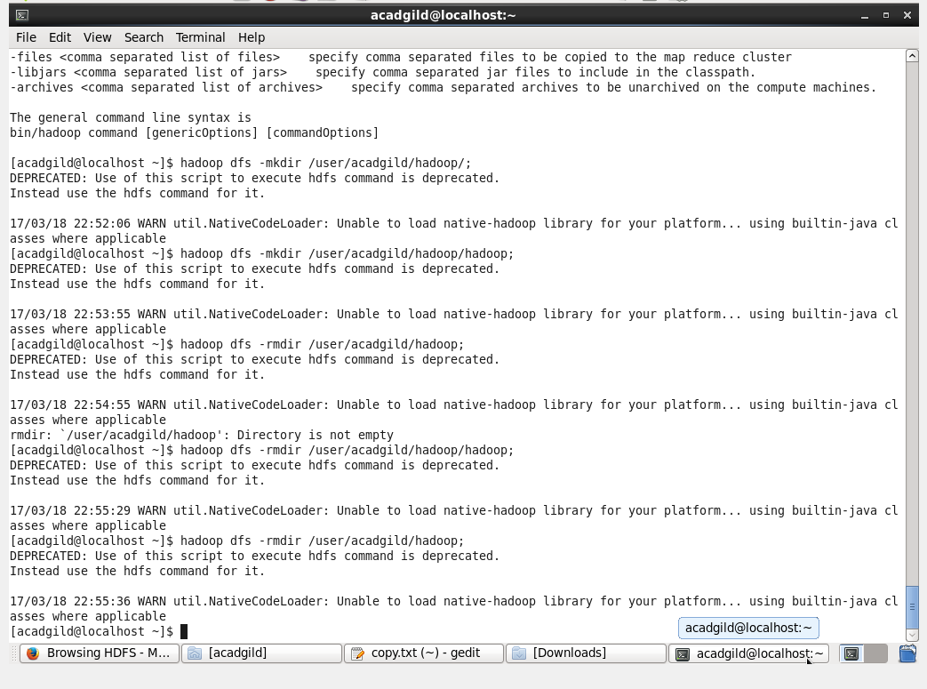

Checking directory and subdirectory in hdfs:

